Create Your Own Copic Background with 7 Kids Craft Store’s Tree House Faeries
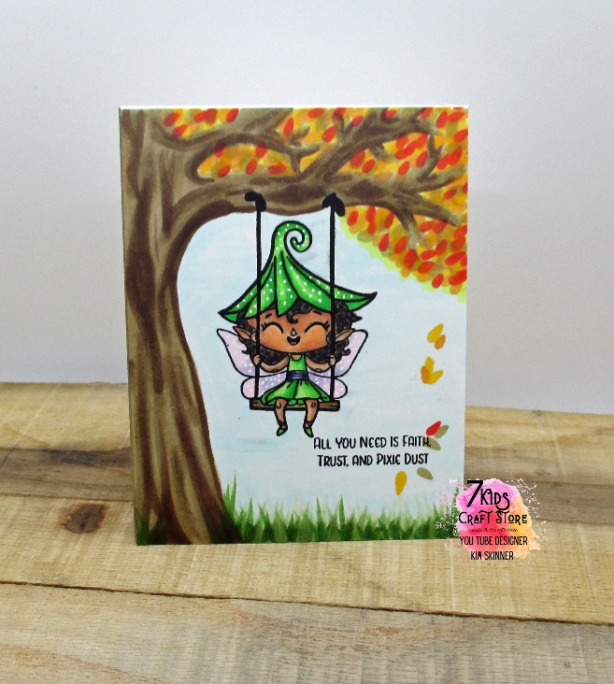

Copic Color Combinations:
Faery:
Skin: E00, 04, 11, 13
Dress and hat: YG 6, 7 ,9, 11
Belt: BV02, 08
Hair: W0, 5, 7, 9
Wings: V000, BV02
Sky: B0000
Tree: E43, 44, 47
Grass: G61, 63, 67
Leaves: Y 11, 28, 35 R24, YR 12

